Mallarmé, Stéphane (Étienne) (1842-1898)

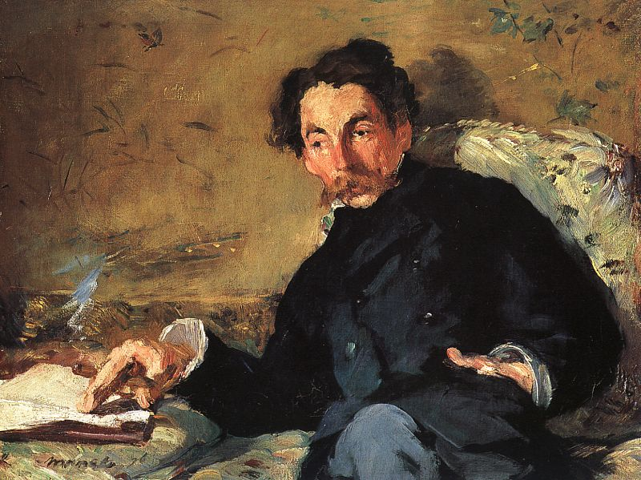
(Mallarmé by Manet, wikimedia commons)

Along with Arthur Rimbaud and Paul Verlaine, Stéphane Mallarmé is a preeminent poet of the latter part of the 19th century, notably as the head of Symbolism (with Verlaine). Like many of his generation, Mallarmé built upon Charles Baudelaire, Théophile Gautier and Edgar Allan Poe’s contributions to poetry and criticism, and anticipated the various Modernist and avant-garde movements to come, being a key voice of modernism. Mallarmé is mostly known for his very difficult, hermetic language, for his conceptualisation of a “crisis of verse” (“crise de vers”), and for his innovations in versification and free verse.

Timeline

1842 birth
1847-48 mother dies father remarries
1855 expelled from school
1857 sister dies, early poems
1860 fails secondary exams
1862 marriage
1863 Tournon
1867-69 years of difficulty, doubt, and failure
1879 Death of son Anatole
1884-1889 Growing fame
1890 lectures in Belgium and in Paris
1894 lectures at Oxford and Cambridge
1896 elected as Prince of Poets (head of Symbolists)
1898 death on 9th of September

Timeline of works

1864-67 Hérodiade
1969 Igitur
1876 L'Après-midi d'un faune
1878 Les Mots anglais
1879 Les Dieux antiques
1887 Poésies
1897 Divagations, Un coup de dés jamais n'abolira le hasard

Biography

Étienne Mallarmé, commonly known as Stéphane, was born in Paris to Numa Mallarmé, a government administrator, and Élisabeth Desmolins, who died when Stéphane was 5, after which point Stéphane came, along with his sister Maria, under the tutelage of his grandfather. His father remarried Anne-Hubertine Léonide Mathieu, who had three girls and a son. Mallarmé’s performance at school was mediocre, and his teachers at Passy reproached him for his “rebellious and vain character”; he was subsequently expelled in 1855. His first poems date from 1854. He was deeply affected by the death of his sister in 1857, as testified in some early prose (“Ce que disaient les trois cigognes,” “Plainte d’automne”).

After first failing his exams, Mallarmé got his high-school diploma (baccalauréat) in 1860. In November 1862, he travelled to London with Marie Gerhard, whom he would marry in 1863, the year his father died. Mallarmé became an English teacher at Tournon. Marie and Stéphane had their first child, Geneviève, in 1864. The following year, Mallarmé sent Théodore Banville the first version of L'Après-midi d'un faune. In the years between 1864 and 1866, Mallarmé began literary friendships with figures such as Frédéric Mistral, Catulle Mendès, Villiers de L'Isle-Adam, Paul Verlaine and François Coppée. In 1866, the Parnasse contemporain, a well-known poetry journal, published some of Mallarmé’s poems. The same year, he left Tournon for Besançon due to difficulties with teaching and parents of pupils, and a year later, he started teaching in Avignon. The years 1867 to 1869 are difficult as they are characterized by fundamental doubt, and he wrote very little all the way through to 1873. His son Anatole was born in 1871, the same year Mallarmé sought employment in England and subsequently moved to Paris. In 1873, Mallarmé befriended the painter Manet and wrote his famous “Toast funèbre” in honour of Gautier who died the previous year. In 1875, Mallarmé translated Poe’s “The Raven” with illustrations by Edouard Manet. A deluxe edition of L'Après-midi d'un faune appeared in 1876, and the following year Les Mots anglais. His son Anatole died in 1879, which inspired his later poem “Tombeau pour Anatole.” His George Cox-inspired Les Dieux antiques, manuel de mythologie was published in 1880. With the appearance of Verlaine’s Les Poètes maudits (1880) and Huysmans’ À Rebours (1881), both which praise him, Mallarmé became an established literary figure. In the years between 1884-1889, which saw his growing status as a poet, he had an affair with Méry Laurent. His Poésies, the first collection of his poetry, was published in 1887 in the Revue indépendante. In 1890, he gave a series of lectures in Belgium and in Paris, notably on the poet Villiers de L’Isle Adam. In 1894, the year he took his retirement, he gave two now-famous lectures, at Oxford and Cambridge, on the topic of “Music and Letters” (La Musique et les Lettres). When Verlaine died in 1896, Mallarmé was elected as the “Prince des Poètes” which confirmed his status and influence on subsequent generations of poets. The widely read collection of essays, Divagations, was published a year later. Mallarmé died on the 9th of September 1898.

Mallarmé contributed to many aspects of modern poetry. As well as renewing fixed forms such as the alexandrine and the sonnet, he also pushed free verse to new levels with his exploded visual poem Un Coup de dés. He furthermore innovated in terms of prose criticism, writing in a highly difficult style that is marked, as with his poetry, by a tension between syntax and rhythm. In “Contre l’obscurité,” Marcel Proust attacked Symbolism, of which Mallarmé was the chief, for its obscurity of ideas and grammar. However, the obscurity of grammar and ideas are less at stake than the uncanny nature of the images created by the tension between grammar and imagery. His language is known as hermetic, that is, nearly inaccessible, but it is possible to make sense of it through careful reading. Still, it is a style that resists single readings. It is characterized by its openness, and for the possibility of multiple readings afforded by its ambiguities and the polysemia of the vocabulary and sentence structure. Indeed, according to Mallarmé, in a late interview with the Figaro, it is the reader who possess the key to his poetry.

The stated goal of Mallarmé’s style is to allow language to speak on its own, free of the poet. The latter must “relinquish all initiative to the words” (“céder l’initiative aux mots”). When words come into contact with each other, the force produced by such contact will create “sparks,” thus creating a “virtual” play of meanings that only the reader can gather into meaning. He described this process in his famous essay, “Crise de vers” (“Crisis of Verse”), and elsewhere.

Mallarmé was reacting to the common-sense notion of language as simply the communication of ideas or the expression of feelings. Rather, he would create a poetics of the suggestive, the indirect and the evocative (“peindre non la chose, mais l’effet qu’elle produit,” “to paint not the thing, but the effect it produces”). This is similar to a painting by Monet, where the attempt is to evoke the sensations created by the water lilies instead of creating a perfect reproduction of them. Thus, Mallarmé’s language evokes sensation, often through the favouring of space (“spatialization”), of mood and ambiance that would conjure a certain feeling. This was in no way the expression of the poet’s own feelings, but rather the result of high levels of craftsmanship, which continues the work done by the “l’Art pour l’art” (art for art’s sake) movement that has characterized a key aspect of modernism.

The media context in which Mallarmé was reacting is characterized by the 19th-century explosion of the press and the correlative commodification of language, a “mental foodstuff” or “staple,” in which he saw the degradation of the poetic into a “high market of letters.” His language has been characterized as revolutionary (Kristeva) and opening up to democratic formal expression that challenges the language of domination (Rancière, Catani). Some have argued that Mallarmé’s expression, albeit ambiguous, deals within an elitist, hermetic discursive context that is a closed literary circle exemplary of social “distinction” (Bourdieu). More recently, in this line of thought, Mallarmé and fellow symbolists have been analysed as playing not just with formal criteria but with an awareness of “formalities,” something which connects the poetic expression to social discourse (e.g. Durand).

Other ways of thinking the mediality of Mallarmé’s work involve the way in which his poetry reflects other media. Walter Benjamin saw his famous Un Coup de Dés as reproducing newspaper advertisements, something which anticipate poets like Apollinaire and the textual play in Joyce’s Ulysses. Recently, some have seen his poetry as reflecting the then newly emerging cinema, and his poetry has been described as “Cinepoetics” (Wall-Romana).

Mallarmé has had an immense impact upon twentieth-century art and philosophy. He is seen as a primary voice for English-language Modernism, in large part through the writings of Valéry. He was a precursor of Dadaism, Futurism and Surrealism, and was a model for OULIPO insofar as his work plays within the bounds of formal constraint. He has also had an impact upon music, most notably on the compositions of John Cage and Pierre Boulez. In philosophy, Jacques Derrida saw in his poetry the play of “différance,” Maurice Blanchot the literary space and infinite discourse of the literature to come, Alain Badiou discusses him in connection with ontology, and, more recently, French speculative realist Quentin Meillassoux has affirmed Mallarmé’s Un Coup de Dés as (de)coded.

Publications
Hérodiade (1864-1867)
“Brise Marine” (1865)
“Don du Poème” (1865)
L'Après-midi d'un faune (1876)
Preface to William Beckford’s Vathek (1876)
Les mots anglais (1877)
Les Dieux antiques (1880)
Album de vers et de prose (1887)
Pages (1891)
“La musique et les lettres” (1895)
Divagations (1897)
Un coup de dés jamais n'abolira le hasard (1st ed. with preface by Mallarmé, 1897)

Posthumous Publications
Poésies (1899)
Un coup de dés jamais n'abolira le hasard (1914)
Vers de circonstance (1920)
Igitur (1925)
Contes indiens (1927)
Pour un tombeau d'Anatole (1961)

Translations
Le Corbeau d'Edgar Poe (The Raven), illustrations by Édouard Manet (1875)
L'Étoile des fées, W.C. Elphinstone Hope (1881)
Poèmes d'Edgar Poe (1888)
Le Ten o'clock de M. Whistler (1888)

Suggested Reading

Catani, Damian. The Poet in Society. Art, Consumerism and Politics in Mallarmé. New York, Bern, Berlin, Bruxelles, Frankfurt/M., Oxford, Wien: Peter Lang, 2003.
Durand, Pascal. Mallarmé. Du Sens des formes au sens des formalités. Paris: Seuil, 2008.
Lloyd, Rosemary. Mallarmé: The Poet and His Circle. Ithaca: Cornell University Press, 1999. Material Culture and Mass Consumption. Oxford: Basil Blackwell:, 1987.
Meillassoux, Quentin. Le Nombre et la Sirène - Un déchiffrage du Coup de dés de Mallarmé. Paris: Fayard, 2011. => The Number and the Siren : A Decipherment of Mallarmé's Coup de dés, Urbanomic/Sequence Press, 2012.
Millan, Gordon. A Throw of the Dice: The Life of Stéphane Mallarmé. London: Farrar, Straus and Giroux, 1994.
Pearson, Roger. Unfolding Mallarmé: The Development of a Poetic Art. Oxford: Clarendon Press, 1996.
Rancière, Jacques. Mallarmé, la politique de la sirène, Paris: Hachette, 1996 => Mallarmé: The Politics of the Siren (2011), tr. by Steven Corcoran.
Wall-Romana, Christophe. “Mallarmé's Cinepoetics: The Poem Uncoiled by the Cinématographe, 1893-98,” PMLA, Vol. 120, No. 1, Special Topic: On Poetry (Jan., 2005), pp. 128-147.

